# JavaScript

It was Daire’s Role was to provide some JavaScript functionality to the Group F Banking Application. Different JavaScript functionality had to be implemented across the Application so that the project functions as proposed.

## Validation and events

Throughout this application, A lot of JavaScript validation functionality was implemented in order to to make sure the information included in the forms was correct. This can be easily done if the form calls on a JavaScript function. This was done on all of the pages in the *register_pages* folder. The script would read in the values from the IDs in the form and check to see that they contained the right information.

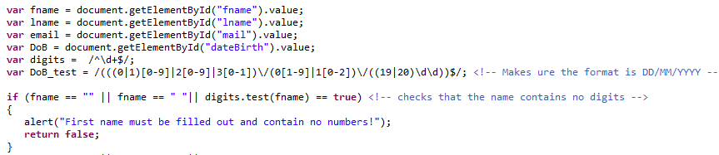

An alert would be returned displaying the error to the user so that they can correct it. This method was applied across all the “Register Pages”.

There was also validation carried out on the *accountPage.jsp* and *adminUser.jsp* pages. For every form in the application, JavaScript validation was used. The “alert()” event was used to inform the user that they had entered in the incorrect syntax in the form field.

## Animations

JavaScript also has the capability to implement some animations. The anime.js script (template from <https://tobiasahlin.com/moving-letters/> ) was used to animate the motto of the GFB (“Fluent in Finance”) across the screen in the *index.html, login.jsp* and *accountPage.jsp* pages. The letters were originally set to be invisible using the opacity setting and then were faded in gradually using the delay function.

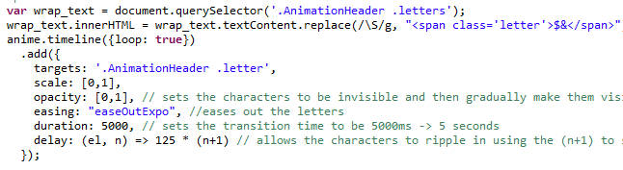

There was also a slideshow done on the index.html page. The basis of this slideshow was taken from <https://www.w3schools.com/w3css/w3css_slideshow.asp> and it was modified to suit the application. There were 3 slides, coupled with captions that showed on screen for 5 seconds and then move onto the next photo.

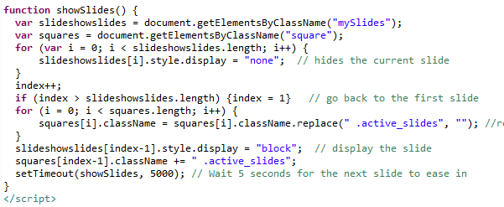

On the *accountPage.jsp*, there was also some JavaScript which took the id and balance of a user passed by the LoginServlet.java page and stored it in local storage.